R Markdown - Assignment 3 in SDS 6103

John Andrew

2024-11-05

Table of Contents

# Illustration of R Markdown Capabilities

## Exploring the Use of R Markdown for Presentations, Notebooks, and Interactive Graphics

This document explores how R Markdown can be used to create presentations, notebooks, and interactive graphics, along with examples for each.

## R Markdown for Presentations

R Markdown supports creating various types of presentations:

1. **HTML Presentations**:
   * **ioslides**: Simple and clean HTML-based slides.
   * **Reveal.js**: Rich with themes, transitions, and interactivity.
   * **xaringan**: Highly customizable, built on remark.js.
2. **PDF Presentations**:
   * **Beamer**: LaTeX-based, suitable for academic and professional presentations.
3. **Microsoft PowerPoint**:
   * Directly generate .pptx files from R Markdown.

### Creating an HTML Presentation with ioslides

Example YAML header for ioslides:

---  
title: "Data Analytics Overview"  
author: "John Andrew"  
output: ioslides_presentation  
---

This will create a basic HTML slide deck with ioslides.

### Creating a PDF Presentation with Beamer

Example YAML header for Beamer:

---  
title: "Statistical Analysis"  
author: "John Andrew"  
output: beamer_presentation  
---

This setup will generate a Beamer PDF presentation with numbered sections.

### Creating a PowerPoint Presentation

Example YAML header for PowerPoint:

---  
title: "Business Intelligence"  
author: "John Andrew"  
output: powerpoint_presentation  
---

This setup outputs directly to a .pptx file.

## Interactive Graphics with Shiny and HTML Widgets

R Markdown can produce interactive graphics using: - **Shiny**: R’s web framework for dynamic, reactive content. - **HTML Widgets**: A collection of R packages for embedding interactive JavaScript widgets like plotly and leaflet.

### Interactive Plot Example (HTML Only)

To ensure compatibility with both HTML and PDF, the code is in HTML output.

library(plotly)  
plot_ly(data = mtcars, x = ~mpg, y = ~hp, type = 'scatter', mode = 'markers')

If i render as HTML, this chunk will display an interactive Plotly scatter plot.

### Interactive Map with Leaflet (HTML Only)

library(leaflet)  
leaflet() %>%  
 addTiles() %>%  
 addMarkers(lng = -122.4194, lat = 37.7749, popup = "San Francisco")

## R Notebooks in R Markdown

An R Notebook is an extension of R Markdown that supports inline execution and interactive analysis.

### Inline Plotting in R Notebook

plot(mtcars$mpg, mtcars$hp,   
 main = "Miles per Gallon vs Horsepower",  
 xlab = "Miles per Gallon",   
 ylab = "Horsepower")

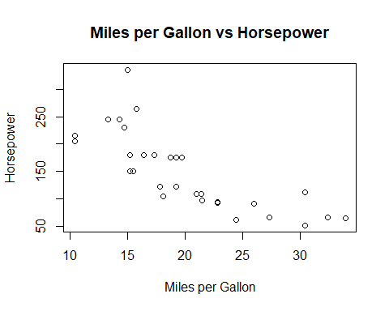

### Using HTML Widgets in R Notebook (HTML Only)

library(DT)  
datatable(mtcars)

## Caching in R Notebooks

R Notebooks support caching, which saves results of computationally expensive code chunks.

Sys.sleep(5) # Simulate a long computation  
sum(rnorm(1e6))

## [1] -547.6498

## Parameterized Reports in R Notebooks

Example YAML for parameterized reports:

---  
title: "Parameterized Report"  
output: html_notebook  
params:  
 sample_size: 20  
 region: "West"  
---

This feature allows flexible, dynamic reports based on parameter values.

## Using Other Language Engines in R Markdown

R Markdown supports different programming languages.

### Python Example (Illustrative Only)

# Python calculation example  
x = 10  
y = 5  
result = x * y  
result

### SQL Example (Illustrative Only)

-- SQL query example  
SELECT * FROM mtcars WHERE mpg > 20

### Bash Example (Illustrative Only)

# Bash command example  
ls -l